Getting Started with MySQL
- Introduction to MySQL
Give a quick introduction to databases and MySQL as a Relational Database Management System (RDBMS)
- Install MySQL
Show you step by step how to install MySQL Server on your computer for practicing with the tutorials.
- Connect to MySQL Server
Walk you through the steps of connecting to the MySQL Server using mysql client program.
- Download a MySQL Sample Database
Introduce you to a sample database called classicmodels and provide you with the link to download it
Summary: in this tutorial, you will learn how to connect to MySQL Server using mysql command-line client and MySQL Workbench. Once you have the MySQL Server installed, you can connect to it using any client program such as mysql command-line client and MySQL workbench.

Connect to MySQL Using mysql command-line client
mysql is a command-line client program that allows you to interact with MySQL in the interactive and non-interactive mode. The mysql command-line client is typically located in the bin directory of the MySQL’s installation folder. To invoke the mysql program, you just simply navigate to the bin directory of the MySQL’s installation folder and type:
mysql
Code language: SQL (Structured Query Language) (sql)
If the mysql program is already in the PATH, you can simply invoke it using mysql command.
To connect to the MySQL Server, you use this command:
shell>mysql -u root -p
Code language: SQL (Structured Query Language) (sql)
-u root means that you connect to the MySQL Server using the user account root.
-p instructs mysql to prompt for a password.
You type the password for the user account root and press Enter:
Enter password: ********
Code language: SQL (Structured Query Language) (sql)
If everything is OK, you will connect to the MySQL Server with the following command:
mysql>
Code language: SQL (Structured Query Language) (sql)
To display the databases in the current server, you use the SHOW DATABASES statement:
mysql> show databases;
Code language: SQL (Structured Query Language) (sql)
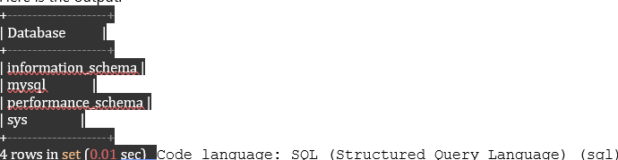

Connect to MySQL Using MySQL Workbench Step 1. Launch the MySQL Workbench.
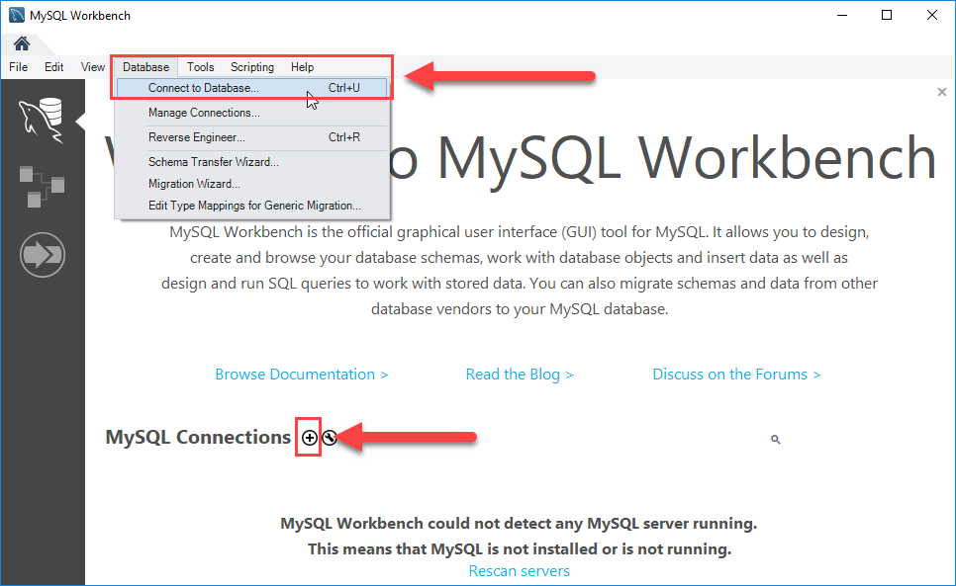
You can connect to a MySQL Server using the Database > Connect to Database… menu or click the + button that locates next to the MySQL Connections. Just click the + button in next to the MySQL Connections to continue.
Step 2. Enter the connection name e.g., Localhost. You can name it whatever makes sense to you. By default, the username is root. If you use a different user account, you can change it in the Username textbox.
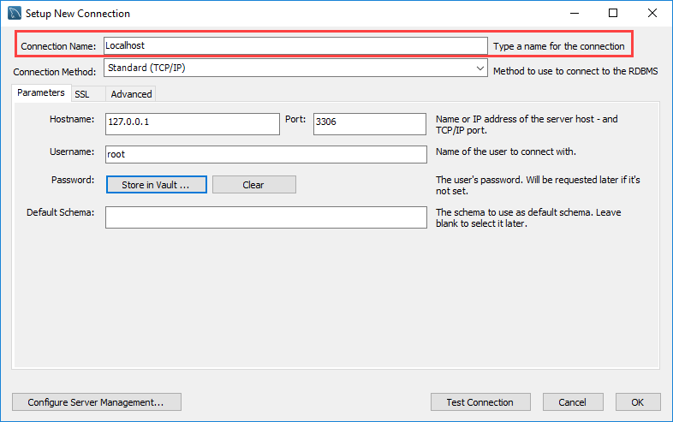Step 3. Click the Store in Vault ... button to enter the password for the provided user account. A window will display. You enter the password and click the OK button.
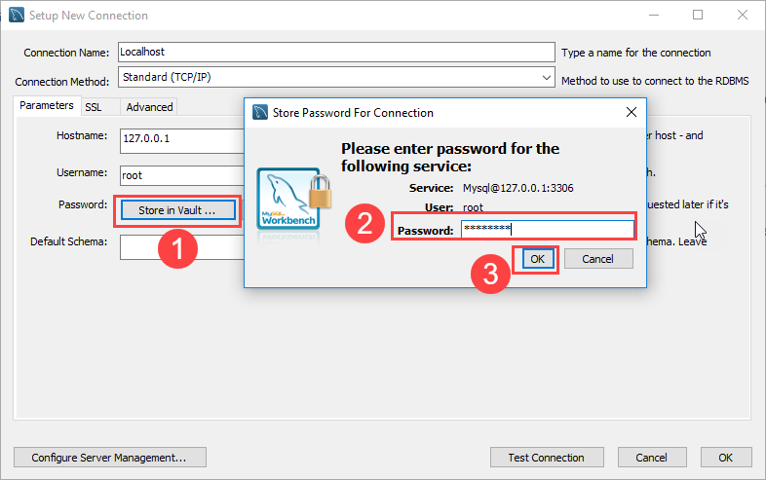Step 4. Click the Test Connection button to test if the connection to the MySQL Server is successful or not. Then click the OK button if the connection is established successfully.
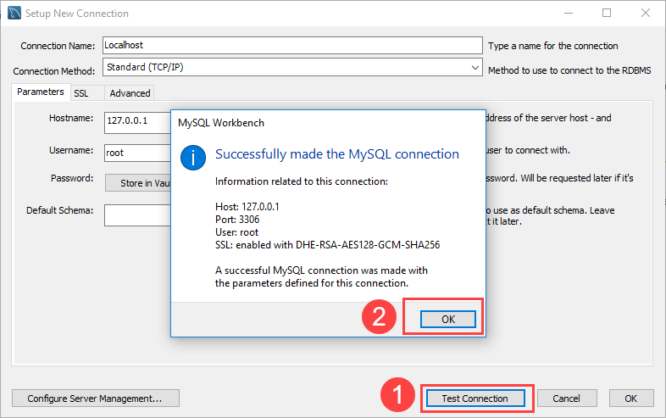Step 5. Click the OK button to save the connection.
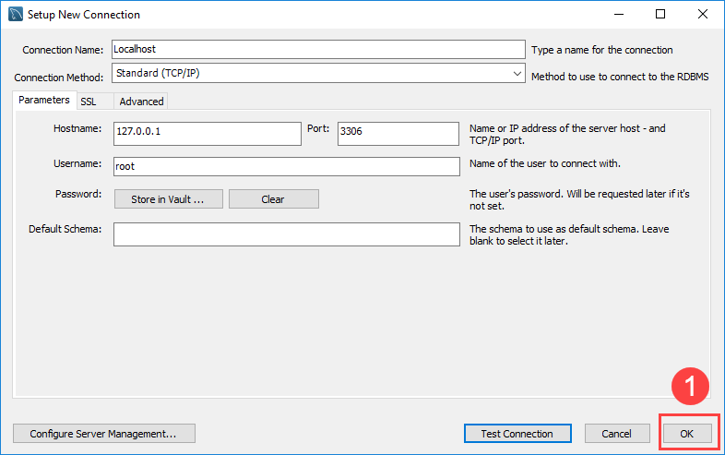
Step 6. Click the newly created connection under MySQL Connections to connect to the MySQL Server:
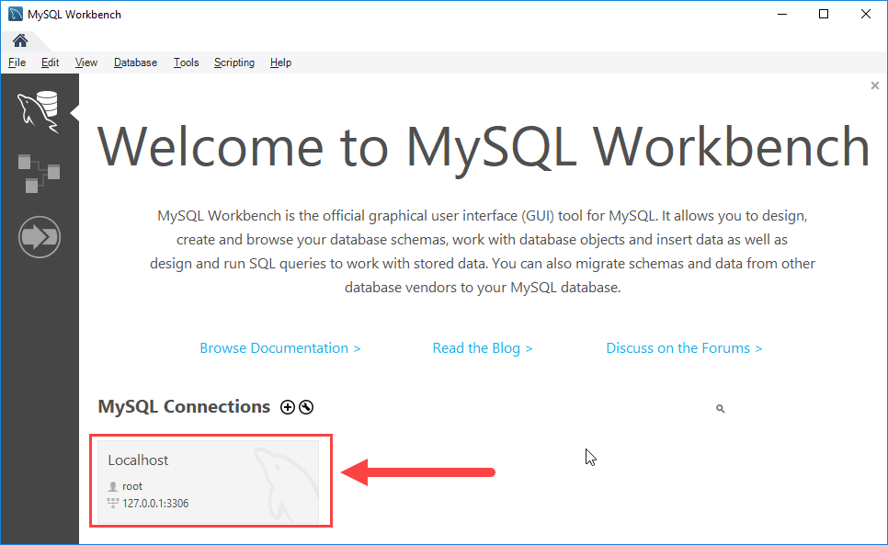
Step 7. MySQL Workbench display with the current schemas and a pane for entering queries:
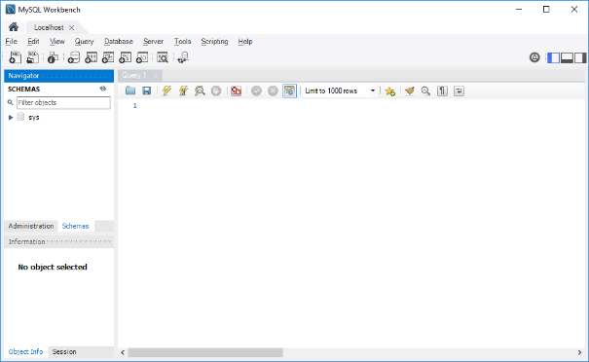In this tutorial, you have learned how to connect to the MySQL Server using mysql command-line client and MySQL Workbench.
Sql1p.sql
SELECT orderdetails.orderNumber, orderdetails.productCode, products.productName
FROM orderdetails, products
WHERE orderdetails.productCode = products.ProductCode
ORDER BY orderNumber;
Sql2p
SELECT orderdetails.orderNumber, orderdetails.productCode, products.productName, products.productLine,
productlines.image
FROM orderdetails, products, productlines
WHERE orderdetails.productCode = products.ProductCode
ORDER BY orderNumber;
Sql2pemp1
SELECT employeeNumber, employees.officeCode, offices.city
FROM employees, offices
WHERE employees.officeCode = offices.officeCode
ORDER BY employeeNumber;
Sql5ord
Select orderNumber, customerNumber from orders
WHERE customerNumber in (select customerNumber from customers)
Sql5count
select productCode, sum(quantityOrdered) total, avg(quantityOrdered) PROM, COUNT(*) FROM orderdetails group by productCode order by productCode
sql7countgby
select customerNumber, sum(amount) Total, avg(amount) PROM, count(*) FROM payments group by customerNumber
sql8countgby
select payments.customerNumber, customerName, sum(amount) Total, avg(amount) PROM, count(*) FROM payments, customers where payments.customerNumber=customers.customerNumber group by customerNumber
sql9countgby
select payments.customerNumber, customerName, sum(amount) Total, avg(amount) PROM, count(*) FROM payments, customers where payments.customerNumber=customers.customerNumber group by customerNumber having sum(amount) >=25000
sql10gbyoby
select orderNumber, sum(quantityOrdered), sum(quantityOrdered * priceEach) TotalO$, count(*) FROM orderdetails group by orderNumber order by orderNumber
sql11gbyoby
Select productCode, sum(quantityOrdered) Totalq, sum(quantityOrdered * priceEach) TotalO$, count(*) FROM orderdetails group by productCode order by productCode
Sql12gbyoby
select orders.orderNumber, productCode, orderDate, quantityOrdered, priceEach FROM orders, orderdetails where orders.orderNumber=orderdetails.orderNumber order by orders.orderNumber
sql14gbyoby
select productCode, RPAD(productName, 35, '.'), LPAD(productName, 30, '.'), products.productLine, SUBSTR(textDescription, 1, 20) Linea from products, productlines where products.productLine=productlines.productLine
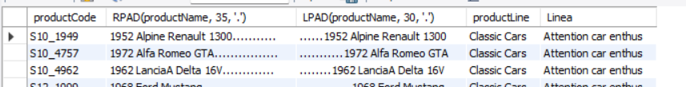
Sql15seldisct clients con pagos
select customers.customerNumber, customerName from customers where customers.customerNumber in (SELECT DISTINCT customerNumber FROM payments)
sql16gcview
create view TotVenxP as select orderdetails.productCode, productName, sum(quantityOrdered), sum(quantityOrdered * priceEach) TotalO$, avg(priceEach), count(*) from orderdetails, products where orderdetails.productCode=products.productCode group by orderdetails.productCode order by productCode
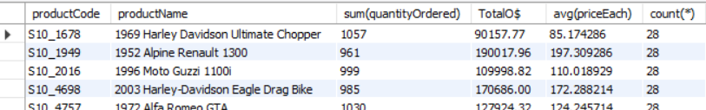
Sql17rpadsub
select productCode, RPAD(productName, 50, '.') Nombre_Producto, products.productLine LINEA, SUBSTR(textDescription, 1, 30) Descripcion_producto, length(textDescription) from products, productlines where products.productLine=productlines.productLine
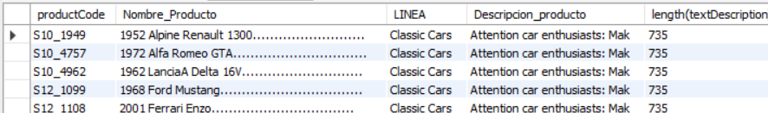
Sql18 date
select orderNumber, orderDate, requiredDate, GREATEST(requiredDate, orderDate), DATEDIFF(requiredDate, orderDate) AS days_between, Sysdate() from orders
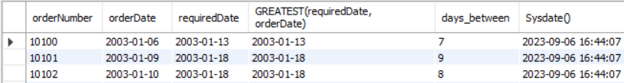
SQL19 DATE
SELECT DATEDIFF(requiredDate, orderDate) AS days_between FROM orders;
Sql20gbyoby
select orderdetails.productCode, sum(quantityOrdered), sum(quantityOrdered*priceEach), count(*) N_Ordenes from orderdetails group by orderdetails.productCode order by productCode
sql21gbyoby
select orderdetails.productCode, productName, productScale, sum(quantityOrdered), sum(quantityOrdered*priceEach), count(*) from orderdetails, products where orderdetails.productCode=products.productCode group by(productCode) order by productCode
sql22gbyoby
select orders.customerNumber, customerName, sum(quantityOrdered), sum(quantityOrdered*priceEach), count(*) from orders, orderdetails, customers where orders.orderNumber=orderdetails.orderNumber and orders.customerNumber=customers.customerNumber group by(customerNumber) order by customerNumber
sql23gbob
select orders.customerNumber, customerName, sum(quantityOrdered), sum(quantityOrdered*priceEach), count(*) from orders, orderdetails, customers where orders.orderNumber=orderdetails.orderNumber and orders.customerNumber=customers.customerNumber group by(customerNumber) order by customerNumber
sql24join
select orderNumber, orderDate, customerName from orders JOIN customers on orders.customerNumber=customers.customerNumber
sql25joingob
select orders.customerNumber, customerName from orders JOIN customers on orders.customerNumber=customers.customerNumber
sql26joingob
select orders.customerNumber, customerName, sum(quantityOrdered*priceEach) $Ordenados, count(*) from orders JOIN customers on orders.customerNumber=customers.customerNumber, orderdetails where orders.orderNumber=orderdetails.orderNumber group by customerNumber
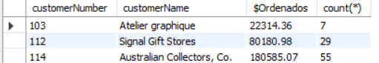
Sql27joingob
select orders.customerNumber, customerName, sum(quantityOrdered*priceEach) $Ordenados, count(*) from orders LEFT JOIN customers on orders.customerNumber=customers.customerNumber, orderdetails where orders.orderNumber=orderdetails.orderNumber group by customerNumber

sql28joingb
SELECT payments.customerNumber, customerName, count(*), sum(amount) FROM payments JOIN customers on payments.customerNumber=customers.customerNumber group by customerNumber
Sql28joinjob
select orders.customerNumber, customerName, sum(quantityOrdered*priceEach) $Ordenados, count(*) from orders RIGHT JOIN customers on orders.customerNumber=customers.customerNumber, orderdetails where orders.orderNumber=orderdetails.orderNumber group by customerNumber
sql30
select orders.customerNumber, count(*), customerName from orders, customers where orders.customerNumber=customers.customerNumber group by(customerNumber)
sql31
select customerNumber, customerName from customers where customerNumber in (select customerNumber from orders group by customerNumber)
sql32
select customerNumber, customerName from customers where customerNumber not in (select customerNumber from orders group by customerNumber)
sql33
select customers.customerNumber, customerName, count(*) from customers JOIN orders On customers.customerNumber=orders.customerNumber group by customerNumber
sqlif33
SELECT orderNumber, status, IF(status= "Shipped", 'despachado', 'Otro') FROM classicalmodels.orders
sqlcase34
SELECT productName, quantityInStock,
CASE
when quantityInStock <=100 then '100 Menos de 100'
when quantityInStock <=1000 then '1000 Menos de 1000'
when quantityInStock <=2000 then '2000 Menos de 2000'
else '2001 Stock mayor a 2000'
END as Cantidad_en_Inv
FROM classicalmodels.products;
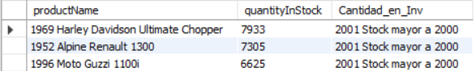
Sqlcase34aview
create view PRODUCTSQIS AS
SELECT productName, quantityInStock,
CASE
when quantityInStock <= 100 then '100 Menos de 100'
when quantityInStock <=1000 then '1000 Menos de 1000'
when quantityInStock <=2000 then '2000 Menos de 2000'
else '2001 Stock mayor a 2000'
END as Cantidad_en_Inv
FROM classicalmodels.products;
Sqlcase34bview
SELECT orderNumber, status, IF(status= "Shipped", 'despachado', 'Otro') FROM classicalmodels.orders
Sqljoingby38
SELECT orderdetails.productCode, productName, buyPrice, MSRP, count(*) FROM orderdetails JOIN products ON orderdetails.productCode=products.productCode group by orderdetails.productCode MSRP precio sugerido
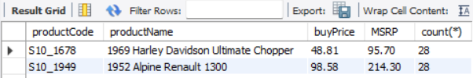
Sql39
set @sumoq=0;
select orderNumber, sum(quantityOrdered), count(*) as NoLineas from orderdetails group by orderNumber
proc1
DELIMITER //
CREATE PROCEDURE get_plane_info()
BEGIN
SELECT a.manufacturer_id, m.manufacturer, COUNT(*) AS plane_count,
ROUND(AVG(a.wingspan), 2) AS avg_span, ROUND(AVG(a.plane_length), 2) AS avg_length
FROM airplanes a INNER JOIN manufacturers m ON a.manufacturer_id = m.manufacturer_id
GROUP BY a.manufacturer_id ORDER BY m.manufacturer;
END//
DELIMITER ;
Proc2
DELIMITER //
CREATE PROCEDURE get_plane_info(
IN in_name VARCHAR(50))
COMMENT 'retrieves aggregated airplane information'
BEGIN
SELECT a.manufacturer_id, m.manufacturer, COUNT(*) AS plane_count,
ROUND(AVG(a.wingspan), 2) AS avg_span, ROUND(AVG(a.plane_length), 2) AS avg_length
FROM airplanes a INNER JOIN manufacturers m ON a.manufacturer_id = m.manufacturer_id
WHERE m.manufacturer = in_name;
END//
DELIMITER ;
Proc3
CREATE OR REPLACE
ALGORITHM = UNDEFINED
DEFINER = `root`@`localhost`
SQL SECURITY DEFINER
VIEW `travel`.`airbus_info` AS
SELECT

`a`.`plane` AS `plane`,
`a`.`engine_type` AS `engine_type`,
`a`.`engine_count` AS `engine_count`,
`a`.`wingspan` AS `wingspan`,
`a`.`plane_length` AS `plane_length`,
`a`.`parking_area` AS `parking_area`
FROM
(`travel`.`airplanes` `a`
JOIN `travel`.`manufacturers` `m` ON ((`a`.`manufacturer_id` = `m`.`manufacturer_id`)))
WHERE
(`m`.`manufacturer` = 'airbus')
ORDER BY `a`.`plane`
Proc4
ALTER
ALGORITHM = MERGE
DEFINER = CURRENT_USER
SQL SECURITY INVOKER
VIEW airbus_info
(plane, engine, count, wingspan, length, area)
AS
SELECT a.plane, a.engine_type, a.engine_count,
a.wingspan, a.plane_length, a.parking_area
FROM airplanes a INNER JOIN manufacturers m
ON a.manufacturer_id = m.manufacturer_id
WHERE m.manufacturer = 'airbus'
ORDER BY a.plane;
Proc5 USE TRAVEL
SELECT a.plane, max_weight AS max_lbs,
lbs_to_kg(max_weight) AS max_kg
FROM airplanes a INNER JOIN manufacturers m
ON a.manufacturer_id = m.manufacturer_id
WHERE m.manufacturer = 'airbus'
ORDER BY a.plane;
Proc6 USE TRAVEL
SELECT m.manufacturer, a.plane,
max_weight AS max_lbs,
lbs_to_kg(max_weight) AS max_kg
FROM airplanes a INNER JOIN manufacturers m
ON a.manufacturer_id = m.manufacturer_id
ORDER BY m.manufacturer, a.plane;
Proc7
SELECT a.emp_id, a.job_title, a.reports_to as A_QUIEN_REPORTA, b.reports_to AS LE_REPORTAN
FROM airline_emps a INNER JOIN airline_emps b
ON a.emp_id = b.reports_to
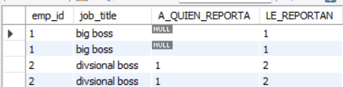
Proc7a
select a.emp_id, a.job_title, a.reports_to AS REPORTA_A, b.emp_id as LE_REPORTA, b.job_title FROM airline_emps a INNER JOIN airline_emps b ON (a.emp_id = b.reports_to) order by a.emp_id
GetEmptyStatus
DELIMITER $$
CREATE PROCEDURE GetEmtyStatus(
OUT Message VARCHAR(100))
BEGIN
DECLARE sum_null DECIMAL(10,2) DEFAULT 0;
SELECT COUNT(*) INTO sum_null FROM TASKS WHERE status IS NULL;
IF sum_null > 0 THEN
SET Message = 'We have rows with NULL!!!';
END IF;
END$$
DELIMITER ;
Funst1
DELIMITER //
CREATE FUNCTION lbs_to_kg(lbs MEDIUMINT UNSIGNED)
RETURNS MEDIUMINT UNSIGNED
DETERMINISTIC
BEGIN
RETURN (lbs * 0.45359237);
END//
DELIMITER ;
Air1
SELECT m.manufacturer, a.plane, a.engine_type, a.engine_count, a.parking_area
FROM airplanes a INNER JOIN manufacturers m ON a.manufacturer_id = m.manufacturer_id
WHERE a.parking_area > 1000 AND max_weight > 10000 ORDER BY a.parking_area DESC, m.manufacturer, a.plane;
Air2
SELECT m.manufacturer, COUNT(*) AS plane_cnt FROM airplanes a INNER JOIN manufacturers m
ON a.manufacturer_id = m.manufacturer_id
WHERE max_weight < 1000000 GROUP BY m.manufacturer_id ORDER BY plane_cnt DESC;
Air3
SELECT m.manufacturer, a.engine_type, COUNT(*) AS plane_cnt
FROM airplanes a INNER JOIN manufacturers m ON a.manufacturer_id = m.manufacturer_id
WHERE max_weight < 1000000 GROUP BY m.manufacturer_id, a.engine_type ORDER BY m.manufacturer ASC, a.engine_type ASC;
Aircte29 Common table expressions cte
WITH planes AS (SELECT plane, engine_count, max_weight FROM airplanes WHERE engine_type = 'jet')
SELECT plane, max_weight FROM planes ORDER BY max_weight DESC;
Aircte30
WITH mfcs AS
(SELECT manufacturer_id, manufacturer FROM manufacturers)
SELECT a.plane, m.manufacturer, a.max_weight
FROM airplanes a INNER JOIN mfcs m
ON a.manufacturer_id = m.manufacturer_id
WHERE a.engine_type = 'jet'
ORDER BY a.max_weight DESC;
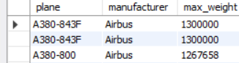
Aircte31
WITH
jets AS
(SELECT plane, engine_type, engine_count, max_weight
FROM airplanes WHERE engine_type = 'jet'),
turbos AS
(SELECT plane, engine_type, engine_count, max_weight
FROM airplanes WHERE engine_type = 'turboprop'),
pistons AS
(SELECT plane, engine_type, engine_count, max_weight
FROM airplanes WHERE engine_type = 'piston')
SELECT * FROM jets
UNION ALL
SELECT * FROM turbos
UNION ALL
SELECT * FROM pistons;
Aircte32
WITH jets AS (SELECT plane, engine_type, engine_count, max_weight FROM airplanes WHERE engine_type = 'jet'),
turbos AS (SELECT plane, engine_type, engine_count, max_weight FROM airplanes WHERE engine_type = 'turboprop'),
pistons AS (SELECT plane, engine_type, engine_count, max_weight FROM airplanes WHERE engine_type = 'piston')
SELECT * FROM jets
UNION ALL
SELECT * FROM turbos
UNION ALL
SELECT * FROM pistons;
Air32b
WITH mfc_weights (id, avg_weight) AS
(SELECT manufacturer_id, ROUND(AVG(max_weight)) FROM airplanes GROUP BY manufacturer_id)
SELECT a.manufacturer_id, a.plane_id, a.plane, a.max_weight, m.avg_weight, (a.max_weight - m.avg_weight) AS amt_over
FROM airplanes a INNER JOIN mfc_weights m ON a.manufacturer_id = m.id
WHERE max_weight > m.avg_weight;
Aircte33
WITH mfcs (id, mfc) AS (SELECT manufacturer_id, manufacturer FROM manufacturers),
mfc_avg (id, mfc, avg_parking) AS (SELECT m.id, m.mfc, ROUND(AVG(a.parking_area))
FROM mfcs m INNER JOIN airplanes a ON m.id = a.manufacturer_id GROUP BY manufacturer_id),
pl_avg (avg_all) AS (SELECT ROUND(AVG(parking_area)) FROM airplanes)
SELECT id, mfc, avg_parking FROM mfc_avg m WHERE avg_parking > (SELECT avg_all FROM pl_avg);
Sqlcase34
SELECT productName, quantityInStock,
CASE
when quantityInStock <=100 then '100 Menos de 100'
when quantityInStock <=1000 then '1000 Menos de 1000'
when quantityInStock <=2000 then '2000 Menos de 2000'
else '2001 Stock mayor a 2000'
END as Cantidad_en_Inv
FROM classicalmodels.products;
Aircte356 recursive
WITH RECURSIVE emps AS
(SELECT emp_id, job_title, reports_to, 1 AS emp_tier, CAST(emp_id AS CHAR(50)) AS emp_path
FROM airline_emps WHERE reports_to IS NULL
UNION ALL
SELECT a.emp_id, a.job_title, a.reports_to, e.emp_tier + 1, CONCAT(a.emp_id, ' / ', e.emp_path)
FROM airline_emps a INNER JOIN emps e ON a.reports_to = e.emp_id)
SELECT * FROM emps ORDER BY emp_tier, emp_id;
Aircte356 b
SELECT emp_id, job_title, reports_to,
1 AS emp_tier, CAST(emp_id AS CHAR(50)) AS emp_path
FROM airline_emps
WHERE reports_to IS NULL
Aircte35 c air
CREATE TABLE airline_emps (
emp_id INT UNSIGNED NOT NULL,
job_title varchar(50) NOT NULL,
reports_to INT UNSIGNED NULL,
create_date TIMESTAMP NOT NULL DEFAULT CURRENT_TIMESTAMP,
last_update TIMESTAMP NOT NULL
DEFAULT CURRENT_TIMESTAMP ON UPDATE CURRENT_TIMESTAMP,
PRIMARY KEY (emp_id),
CONSTRAINT fk_emp_id FOREIGN KEY (reports_to)
REFERENCES airline_emps (emp_id) );
INSERT INTO airline_emps
(emp_id, job_title, reports_to)
VALUES
(1, 'big boss', NULL),
(2, 'divsional boss', 1),
(3, 'supervisor', 2),
(4, 'chief', 2),
(5, 'designer', 3),
(6, 'top exec', 1),
(7, 'overseer', 6),
(8, 'team leader', 6),
(9, 'organizer', 8),
(10, 'controller', 8),
(11, 'specialist', 10),
(12, 'analyst', 9);
SELECT * FROM airline_emps;
Aircte37 withupdate
WITH rpts AS
(SELECT emp_id FROM airline_emps WHERE reports_to = 8)
UPDATE airline_emps SET reports_to = 7 WHERE emp_id IN (SELECT * FROM rpts);
Aircte38
WITH RECURSIVE emps AS
(SELECT emp_id, job_title, reports_to, 1 AS emp_tier, CAST(emp_id AS CHAR(50)) AS emp_path
FROM airline_emps WHERE reports_to IS NULL
UNION ALL
SELECT a.emp_id, a.job_title, a.reports_to, e.emp_tier + 1,
CONCAT(a.emp_id, ' / ', e.emp_path)
FROM airline_emps a INNER JOIN emps e ON a.reports_to = e.emp_id)
SELECT * FROM emps ORDER BY emp_tier, emp_id;
Airinsert4
INSERT INTO airplanes
(plane_id, plane, manufacturer_id, engine_type, engine_count, wingspan, plane_length, max_weight, icao_code)
VALUES (401,'Learjet 24A',1007,'Jet',2,35.58,43.25,12499,'LJ24');
Airinsert7
INSERT INTO airplanes (plane, manufacturer_id, engine_type, engine_count, wingspan, plane_length, max_weight, icao_code)
VALUES
('Challenger (BD-100-1A10) 300',1007,'Jet',2,63.83,68.75,38850,'CL30'),
('Challenger (BD-100-1A10) 350',1007,'Jet',2,69,68.75,40600,'CL30'),
('Challenger (CL-600-1A11) 600',1007,'Jet',2,64.33,68.42,36000,'CL60'),
('Challenger (CL-600-2A12) 601',1007,'Jet',2,64.33,68.42,42100,'CL60');
Airinser8 airinsert9
CREATE TEMPORARY TABLE airplanes_temp (
plane VARCHAR(50) NOT NULL,
manufacturer_id INT UNSIGNED NOT NULL,
engine_type VARCHAR(50) NOT NULL,
engine_count TINYINT NOT NULL,
wingspan DECIMAL(5,2) NOT NULL,
plane_length DECIMAL(5,2) NOT NULL,
max_weight MEDIUMINT UNSIGNED NOT NULL,
icao_code CHAR(4) NOT NULL);
airinsert10
INSERT INTO airplanes (plane, manufacturer_id, engine_type, engine_count, wingspan, plane_length, max_weight, icao_code)
SELECT plane, manufacturer_id, engine_type, engine_count, wingspan, plane_length, max_weight, icao_code
FROM airplanes_temp WHERE manufacturer_id = 1007;
Airinsert11
INSERT INTO airplanes
(plane, manufacturer_id, engine_type, engine_count, wingspan, plane_length, max_weight, icao_code)
TABLE airplanes_temp;
Airupdate11
SET SQL_SAFE_UPDATES = 0;
UPDATE airplanes
SET wingspan = ROUND(wingspan);
SET SQL_SAFE_UPDATES = 1;
Airupdate12
UPDATE airplanes SET engine_type = 'piston (adg-i)' WHERE manufacturer_id = 1008;
Airupdate14
UPDATE airplanes SET engine_type = 'piston (adg-ii)' WHERE manufacturer_id = 1008 AND plane = 'B.206';
Airupdate15
SET foreign_key_checks = 0;
UPDATE manufacturers SET manufacturer_id = 2001 WHERE manufacturer_id = 1008;
UPDATE airplanes SET manufacturer_id = 2001 WHERE manufacturer_id = 1008;
Airupdate16
SET foreign_key_checks = 1;
UPDATE airplanes SET plane_id = plane_id + 1 WHERE manufacturer_id = 2001 ORDER BY plane_id DESC;
Airsub18
SELECT plane_id, plane FROM airplanes WHERE manufacturer_id IN
(SELECT manufacturer_id FROM manufacturers WHERE manufacturer = 'Beechcraft');
Airsub19
SELECT plane_id, plane, max_weight FROM airplanes WHERE max_weight > (SELECT AVG(max_weight) FROM airplanes);
Airsub20
SET @avg_weight = (SELECT ROUND(AVG(max_weight)) FROM airplanes);
SELECT plane_id, plane, max_weight FROM airplanes WHERE max_weight > @avg_weight;
Airsub21
SELECT m.manufacturer_id, m.manufacturer, a.plane_id, a.plane, a.max_weight
FROM airplanes a INNER JOIN manufacturers m ON a.manufacturer_id = m.manufacturer_id
WHERE a.max_weight > (SELECT ROUND(AVG(max_weight)) FROM airplanes a2
WHERE a.manufacturer_id = a2.manufacturer_id);
Airsub22
SELECT manufacturer_id, plane_id, plane, max_weight, (SELECT ROUND(AVG(max_weight)) FROM airplanes a2
WHERE a.manufacturer_id = a2.manufacturer_id) AS avg_weight FROM airplanes a WHERE max_weight >
(SELECT ROUND(AVG(max_weight)) FROM airplanes a2 WHERE a.manufacturer_id = a2.manufacturer_id);
Airsub23
SELECT manufacturer_id, plane_id, plane, max_weight, (SELECT ROUND(AVG(max_weight)) FROM airplanes a2
WHERE a.manufacturer_id = a2.manufacturer_id) AS avg_weight,
-- subtracts average weight from max weight
(max_weight - (SELECT ROUND(AVG(max_weight)) FROM airplanes a2
WHERE a.manufacturer_id = a2.manufacturer_id)) AS amt_over FROM airplanes a WHERE max_weight >
(SELECT ROUND(AVG(max_weight)) FROM airplanes a2 WHERE a.manufacturer_id = a2.manufacturer_id);
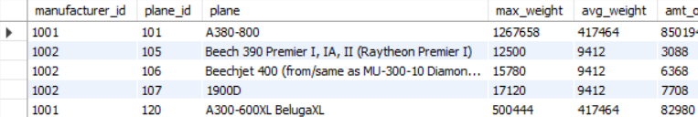
Airsub25
SELECT manufacturer_id, manufacturer FROM manufacturers
WHERE manufacturer_id IN (SELECT DISTINCT manufacturer_id FROM airplanes WHERE engine_type = 'piston');
Airsub26
SELECT manufacturer_id, manufacturer FROM manufacturers m WHERE EXISTS (SELECT * FROM airplanes a
WHERE a.manufacturer_id = m.manufacturer_id);
Airsub27
SELECT ROUND(AVG(amount), 2) AS avg_amt FROM
-- outer subquery aggregates categories and calculates count for each one
(SELECT category, COUNT(*) amount FROM
-- inner subquery categorizes planes based on parking area
(SELECT CASE
WHEN parking_area > 50000 THEN 'A'
WHEN parking_area >= 20000 THEN 'B'
WHEN parking_area >= 10000 THEN 'C'
WHEN parking_area >= 5000 THEN 'D'
WHEN parking_area >= 1000 THEN 'E'
ELSE 'F'
END AS category FROM airplanes) AS plane_size GROUP BY category ORDER BY category) AS plane_cnt;
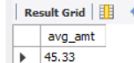
Airsub27a
SELECT category, COUNT(*) amount FROM
-- inner subquery categorizes planes based on parking area
(SELECT CASE
WHEN parking_area > 50000 THEN 'A'
WHEN parking_area >= 20000 THEN 'B'
WHEN parking_area >= 10000 THEN 'C'
WHEN parking_area >= 5000 THEN 'D'
WHEN parking_area >= 1000 THEN 'E'
ELSE 'F'
END AS category FROM airplanes) AS plane_size GROUP BY category
